PML Final Project Report
CS4771 – Python for Machine learning
12/14/2025
Todd Carter, Bryce Normile, Jake Gendreau
Title: | Predicting the End: A Machine Learning Study of Crocodile Extinction
Introduction and Problem Statement | This project is a machine learning exercise designed to allow the participants to practice and experiment with linear regression using Python. To expand on the skills involved, a model that examines ecological data to study the decline of crocodilian species was produced using techniques introduced over the semester.  The goal of the study is to identify species of crocodilians that are at greater risk of extinction, and if possible, to provide relatively times as to when any individual species might no longer be recordably present in their environment. This will provide potentially valuable insights into the impact of human activity on the natural environment which can be used for better reducing that impact in the future.  Such ecological data is currently becoming more difficult to produce and to find. The political climate of the world has significant reduced the amount of data available for studying climate change. This study into crocodilian extinction hopes to highlight the issue by using a relatively popular reptilian to draw attention to the problem. This can generate human interest which better drives support for solutions.
Methodology and Approach | The methodology followed was a relatively simple XGB Classifier model. Classification was chosen as the method due to the large number of labeled columns in the various datasets used. Like other models, this required acquiring data that was correlated by common information such as country and name, and then preprocessing that data into one corpus.  This corpus of data was built from three datasets that had common columns, “Global Crocodile Species Dataset,” “Carbon (C02) Emissions By Country” and “Global Energy Consumption.” Each of these datasets contained information regarding specific countries that they had in common, indicating countries that contained both crocodiles and information commonly connected to climate change. All of these datasets came from what was publicly available on Kaggle.  Larger and more detailed datasets were sought out, though during the aggregation phase, it was discovered that many datasets regarding conservation and climate change were no longer available due to political reasons. Further, many datasets utilized graphical mapping information rather than numerical data, which strayed outside the boundaries of a classification model. This limited the amount of datasets that were available, though preprocessing the data did still yield final results.  During preprocessing, a list of named countries was used as a map to unite the three relevant datasets along their common columns. Discrepancies between the datasets meant that the country names then had to be normalized, which entailed extracting the country name alone and appending it to a generic prefix. Then, the datasets were combined using commonalities, such as the year of data observation in CO2 and the year extracted from the date of observation of a particular species of crocodile. This merged the three datasets into one, which was then further processed by padding out deficient columns and removing duplicates, and then finally one-hot-encoding the “Scientific Name” and “Country” columns to provide added context.  Checking the feature importance showed that the “Scientific Name” columns proved to be the most useful for the final classification, as shown in Figure 1.  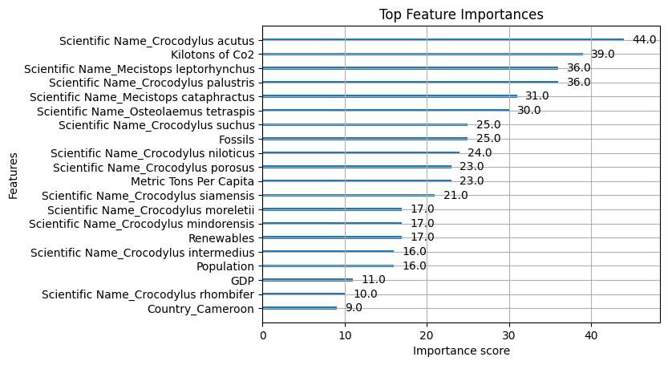  Figure 1: Feature Importance table  With the final dataset in hand, the model was then trained and tuned with an established set of hyperparameters, which were optimized by RandomizedSearchCV. XGBClassifier was selected for the model due to being a good fit for the type of data present and due to familiarity of the project participants. F1 scores were calculated along the way to test the viability of the training and end results, shown in the confusion matrix in Figure 2.  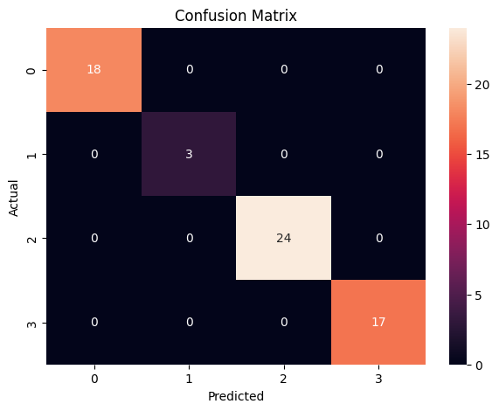  Figure 2: F1 Confusion Matrix  The confusion matrix shows there was little to no confusion in the XGBoost model. This indicates reliable predictions across all features, though this was not always supported by the calculation of F1 scores during further analysis.  The software use was VSCode, Visual Studio, and Python. Python libraries include numpy, pandas, matplotlib, xgboost, seaborn, and sklearn. No cloud computing services were required and the project was able to run locally through Kaggle’s notebooks.
Results and Analysis | The given parameters and fitting of the model was required to be stretched over several datasets, which meant using a relatively thin amount of data of around three hundred lines. Results were further damaged by the frequency of interaction between available data, with duplicates and cross overs needing to be removed or padded out.  This resulted in a high number of very low F1 scores where the data was not sufficient for training, as seen in Figure 3.  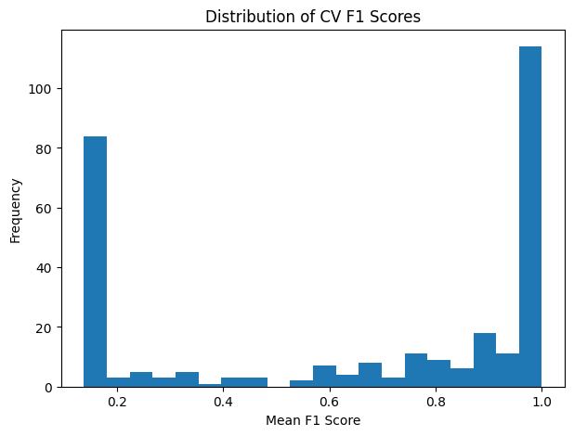  Figure 3: Table of Scores  Though high scores outweighed the low scores, this still indicates a lack of overall accuracy and recall in the final results. This shows that the resulting data could be interesting though is not as detailed or trustworthy as it could have been should larger and much more detailed datasets had been found. Unfortunately, during data aggregation, it became clear that many  These results showed a disappointing lack of clear conclusion, though this could be argued as being indicative of a negative result as well.  The issue with a lack of data was made clear in the final results. As shown in Figure 4, there was only upwards of five endangered species observed per year over the course of the twenty years of data in this study. This low number would have been alleviated with a much longer period of data of collection, though such longer datasets were not available. As the case may be, this amount of data can only provide so accurate of a result.  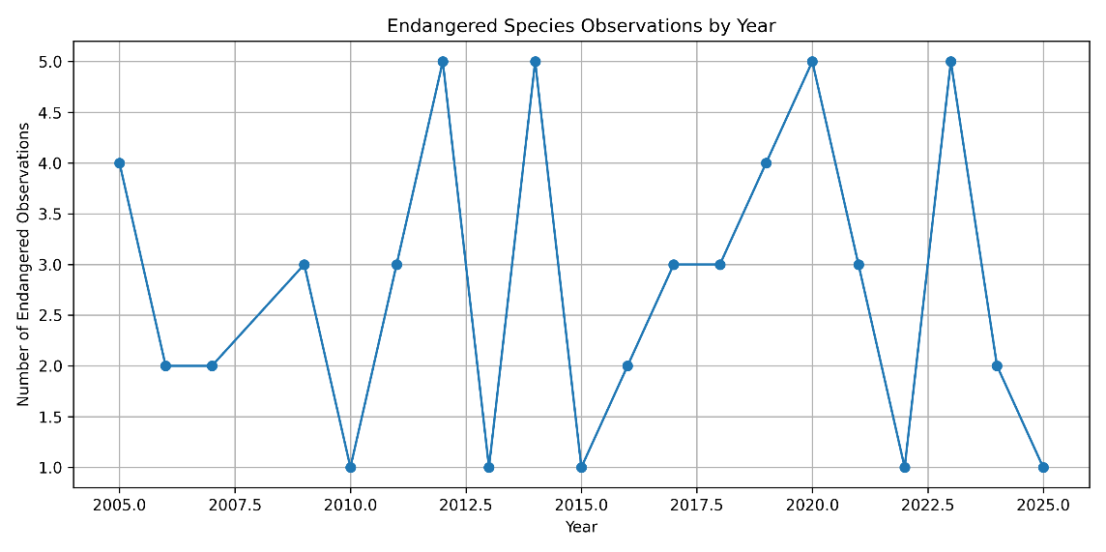  Figure 4: Chart of number of observations made for endangered species of crocodiles over a twenty year span.  This relatively low frequency of observation could explain the final results of this particular model, in which little to no overall population change was observed. These results indicate that crocodile species, though many are at dangerously low numbers, have been holding steady where they are found across the globe, as shown in Figure 5.  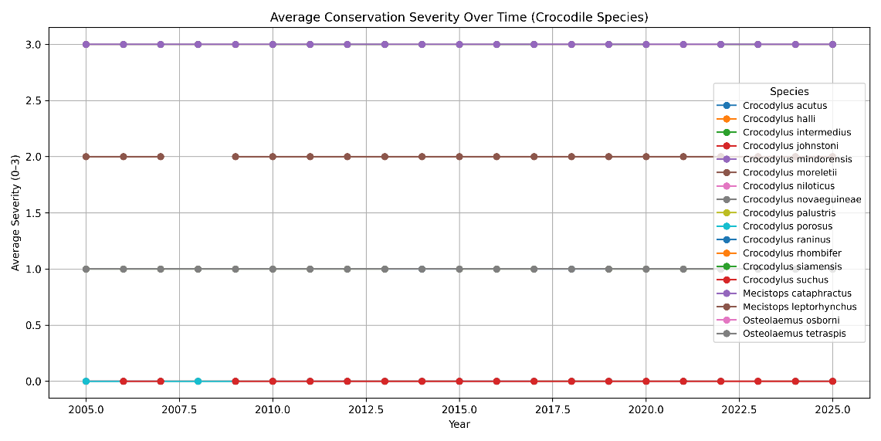  Figure 5: Chart showing the change in crocodile conservation severity over time.  This could further indicate that conservation efforts are either succeeding or are not as required for a species such as crocodiles. The past twenty years has seen rising amounts of attention to conservation matters across the globe which could help be responsible for maintaining crocodile numbers. Crocodilian species are also hardy for their environments, and with global conservation on the rise, this machine learning study might indicate they do not serve well as an indicator for ecological change.
Datasets | - Global Crocodile Species Dataset (https://www.kaggle.com/datasets/zadafiyabhrami/global-crocodile-species-dataset).  - This dataset contains over a thousand entries about a wide range of crocodile species gathered from around the world. This will provide a core set of data for the machine learning model by observing the endangered status of each given species in their native country and habitat.  - Features used include: scientific name, date of observation, and country.  - The dataset must be cleaned up during preprocessing, as there are null entries in each of the relevant features. Unnecessary columns will be dropped and dates will be reprocessed to be standard numerical formats.  - Carbon (CO2) Emissions By Country (https://www.kaggle.com/datasets/ravindrasinghrana/carbon-co2-emissions).  - This dataset contains data about yearly carbon dioxide emissions per country all over the world. This will provide context for the machine learning model by cross-referencing the rate of species decline or inclination as compared to the rate of carbon dioxide released by each country.  - Features used will include: country, date, and kilotons (of CO2).  - The data set will need to be merged into the Global Crocodile Dataset using dates and countries. This will require processing the date and country into usable numeric values.  - Global Energy Consumption (2000 – 2024) (https://www.kaggle.com/datasets/atharvasoundankar/global-energy-consumption-2000-2024)  - This dataset includes information about the usage of different fuel sources by countries from around the world. This provides data on carbon emissions by each country per year which can be used for further refinement.  - Features used will include: Country, year, and carbon emissions.  To be preprocessed, this dataset will need to be compared to Carbon (CO2) Emissions that will also be used in this study. The two datasets share enough commonality that overlapping information must be found and removed before training.
Conclusion | Though this study was ultimately inconclusive as to whether or not crocodile populations that are already in some level of endangerment are at a continued or greater risk, it did provide a potentially more hopeful perspective on the same issue. Indications that crocodilian populations are maintaining across the globe is a positive sign that ecological damage from climate change has not yet reached the large predator populations of the globe.  Though twenty years of data is a long span, this project further highlights how certain kinds of data become more useful when they are gathered over an even longer span. Stable data sources such as the population numbers for crocodilian species could be more useful if gathered from over a longer period of time. This might then show measurable differences in the population if data could have been recorded from decades further back.  Regardless, this study could be used as support for conservation efforts already in play, while also giving minor relief as to where ecological collapse might be the worst. The results indicate that for over the course of twenty years, crocodiles have continued to prove themselves to be tough, hardy survivors, even in a world with the modern changing climate.
Collaboration Plan: | - Bryce Normile - Model selection, training, tuning  - Jake Gendreau (V00940188) - Data aggregation + preprocessing  - Todd Carter (V01187982) – Documentation + data aggregation
References: | - Global Crocodile Species Dataset (https://www.kaggle.com/datasets/zadafiyabhrami/global-crocodile-species-dataset)  - Carbon (CO2) Emissions By Country (https://www.kaggle.com/datasets/ravindrasinghrana/carbon-co2-emissions).  - Global Energy Consumption (2000 – 2024) (https://www.kaggle.com/datasets/atharvasoundankar/global-energy-consumption-2000-2024)

